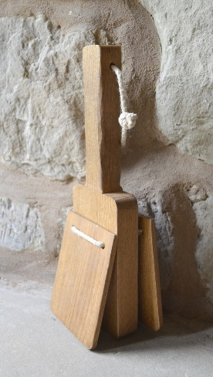 | This is a bird scarer, which would have been used by young boys and girls to chase birds a way from farm crops and garden plants as they are growing.
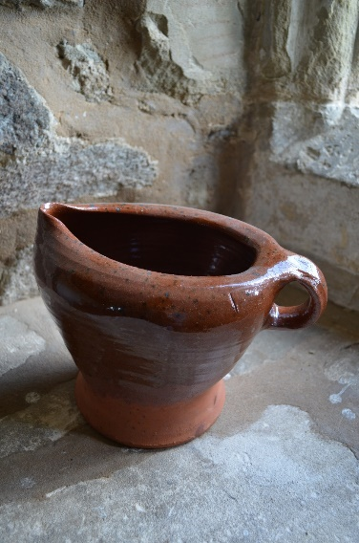 | This is a type of chamber pot. These were used like potties by people of all ages as most people didn’t have any form of foxed toilet in the 1620s. They wold have been kept under the bed and in the corner of the main living and dining rooms.
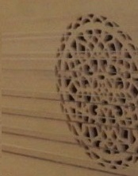 | This is a lute, a sort of early guitar based on Middle eastern musical instruments. Lutes were very popular in Medieval, Tudor and Stuart times.
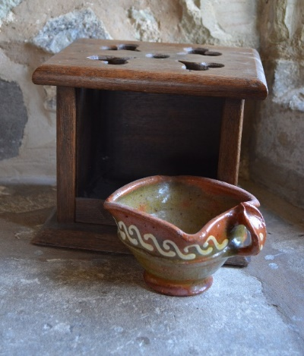 | This a heated foot stool. A servant would put some hot burning wood or coal in the pot, and then the pot would be placed inside the box and under a desk or in front of a chair, so the owner could keep their toes warm. Stuart houses had no central heating, just fires in certain rooms of the house. England was a lot colder then too.
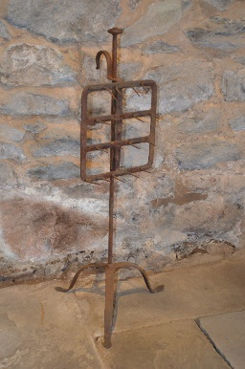 | The spikey iron frame was used to roast small birds, such as larks and quail in front of an open fire.
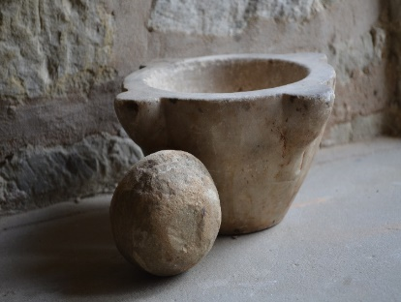 | This stone pot and the round stone would be used together to grind up ingredients for cooking. It is called a pestle (the stone) and mortar (the bowl). Smaller versions of these are used in chemistry labs.
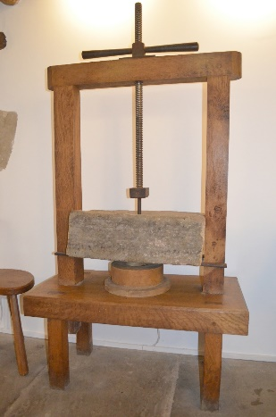 | This large wooden frame has a heavy stone weight which is lowered and raised by the iron handle at the top. It is used to press down on newly made hard cheeses, such as Cheddar, to squash all the liquid out for them so they will stay fresh for longer.
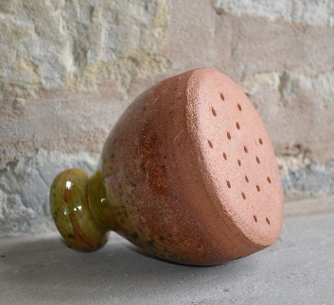 | This pot had a hole at the top as well as at the bottom. It is a clever design of a plant watering pot. The pot is put into a bucket of water then the top hole is covered with a thumb. This causes the water inside to stay still because it is in a vacuum. Once the thumb is moved, the water sprinkles out onto the plant.
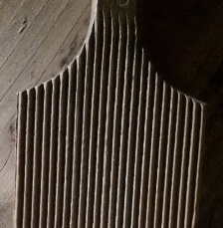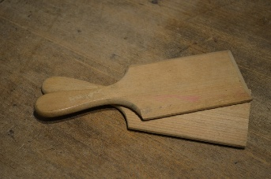 | These are butter pats or paddles and were used to squeeze the liquid out newly made butter and from into into blocks like we still buy today. Butter had to be kept in a cold room as they had no fridges then.
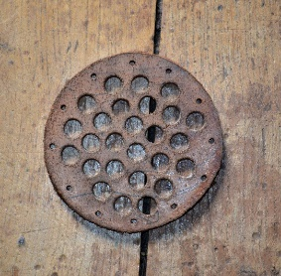 | This leather object was stitched into a linen arrow bag to protect the feather flights at the top of the arrows from getting damaged.
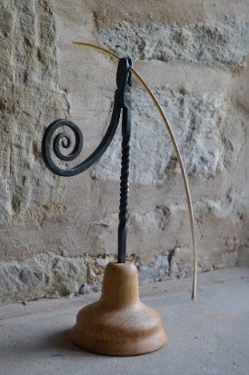 | This iron device was used to hold wax or animal fat covered string, straw or wood, called rush lights or tapers, which wold be burnt like a candle.
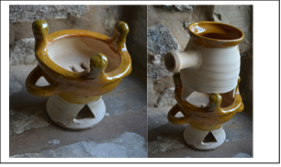 | This pot is the base of a chafing dish set. A small fire was set in the lower pot to keep sauce or soup in the upper pot warm in the cold house. We still use this today in Chinese restaurants.
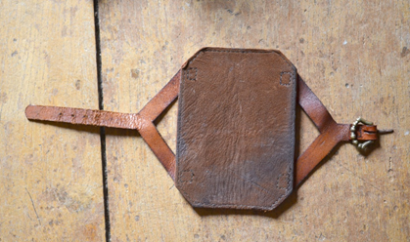 | This leather object is another part of an archer’s kit. It is worn on the left wrist to stop the archer being bruised there by the bowstring when they loose an arrow.
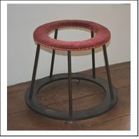 | This strange looking frame has little wheels on the bottom and is padded on top. It was used to help very small children learn to walk.
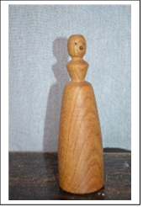 | The little face on the top of this object shows us that it is a doll. Children would glue bits of cloth to the wooden body to make clothes for it. Some dolls with moving arms and legs are known form Stuart times, but they would have been rare and expensive.
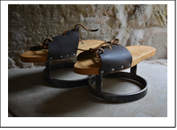 | These are over shoes, called ‘pattens’. They are a bit like clogs and the iron rings underneath would have keep the wearer’s shoes and clothing out of the animal and human muck that wold have been in the city streets.
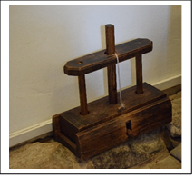 | This strange looking device was used to kill mice. The heavy wooden block at the bottom would be lifted up and set in place by a wooden pin on the string. A small tray underneath would be set with bait, such as cheese or something sweet and put onto the pin. When the mouse touched the tray, the pin would move and SPLAT! The block would fall on the mouse.
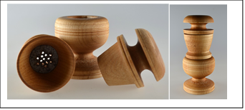 | This three-piece wooden object would be used in the kitchen. The part with lots of holes in is an iron grater and it was used to grind spices, such as pepper, cinnamon and cloves. Spices were very expensive and would have been locked away in a special box.
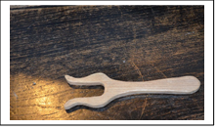 | This small wooden object is a lucet and was used to make cord from wooden and silk thread.
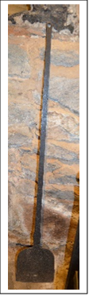 | This long iron spade like object was used to get bread out of the small oven set into the large fireplace, just above the main fire. The handle is long so the user doesn’t get burnt. People making pizzas still use these today to get the finished pizza out of the hot ovens.
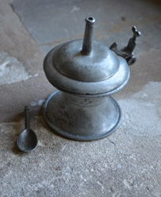 | This small pot is made of pewter, a mixture of lead and tin. It was used to hold salt. The long point on the lid is allow the lid to rest on the table top when open. The little spoon was used to serve the salt. Salt was produced from sea water in Cheshire and East Anglia and was quite expensive, so only the richer people would have it every day.
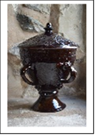 | This large brown jar is a wassail cup. It was used at special times of year for people to drink to each there’s health. Wassail is based on an Anglo-Saxon greeting meaning ‘good health to you!’. It would be filled with spiced cider or wine and passed around, so everyone drank out of the same cup. Although there were a lot of nasty plaques and illnesses back then, people then didn’t understand about germs like we do.
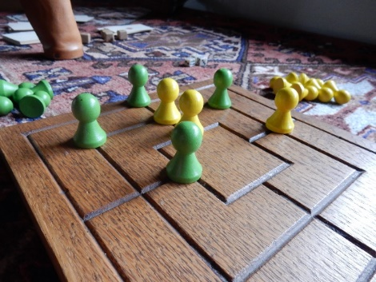 | This is a wonderful old came called Nine Men’s Morris. It was played by the Anglo-Saxons and Vikings and was still popular in the 1600s. It is played a nit like noughts and crosses.
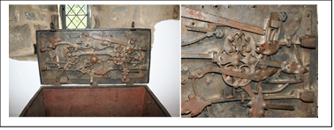 | This elaborate iron lock is from a large and very heavy strong box. These would be used to protect the family’s money, jewels and important documents as not everyone used banks in the Stuart times.
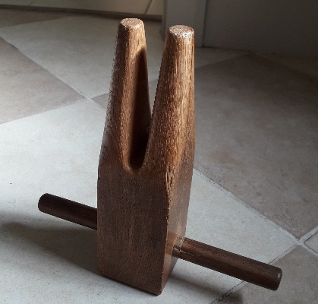 | This object is the most unusual at the house and was used to tighten the ropes which criss-cross across the beds these ropes are to hold up the mattresses that the family slept on. If the ropes are saggy and lose then the family would get back ache, so they would regularly tighten up the ropes and say ‘Good night, sleep tight’.

